

**100W 8x8 Thermal Controller Build guide**

**Parts:**

Figure 1 – Brackets (4)

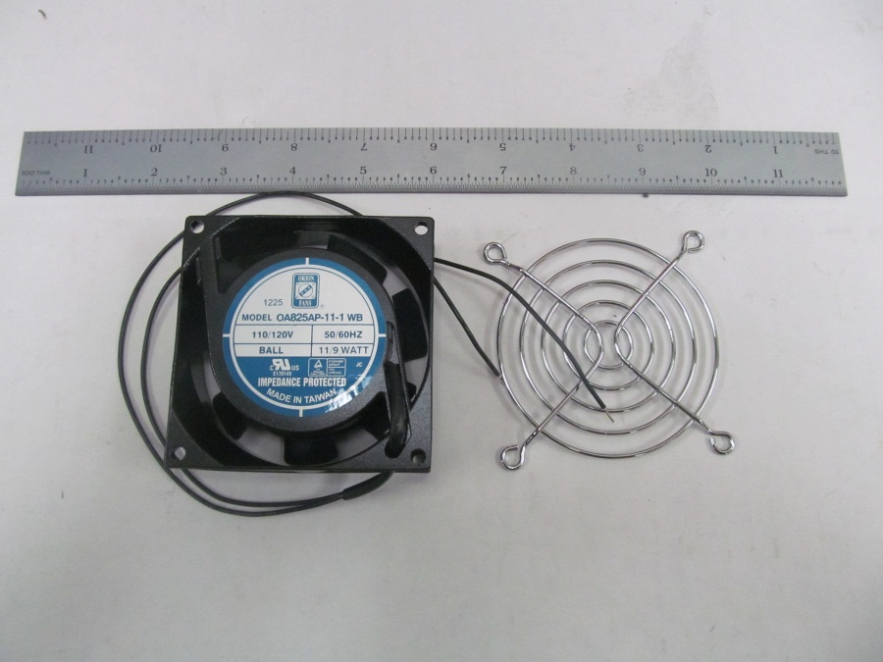

Figure 3 - AC Fan and Fan Guard

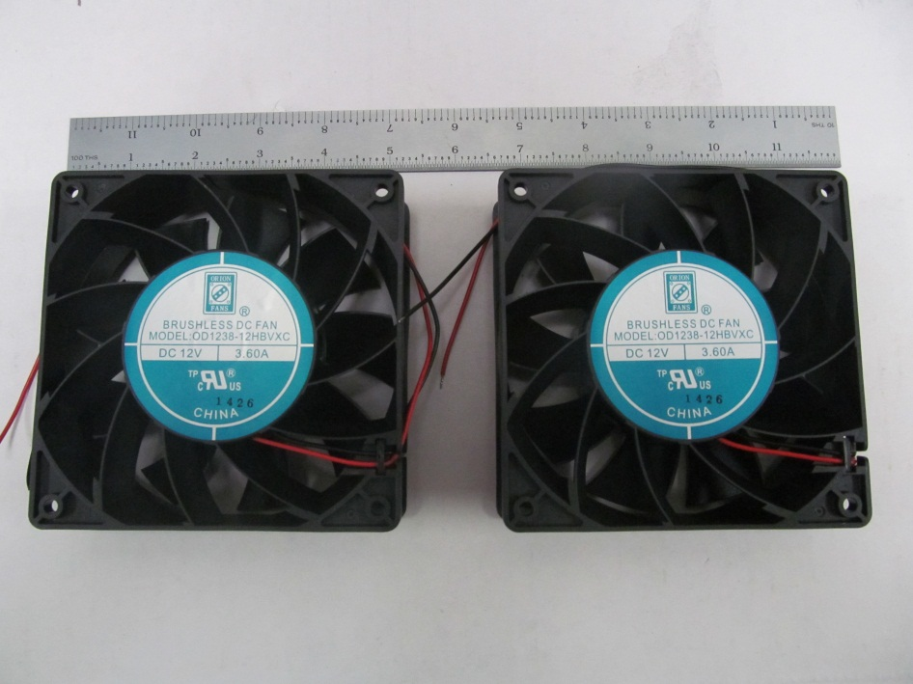

Figure - 12V 3.6A Fan(2)

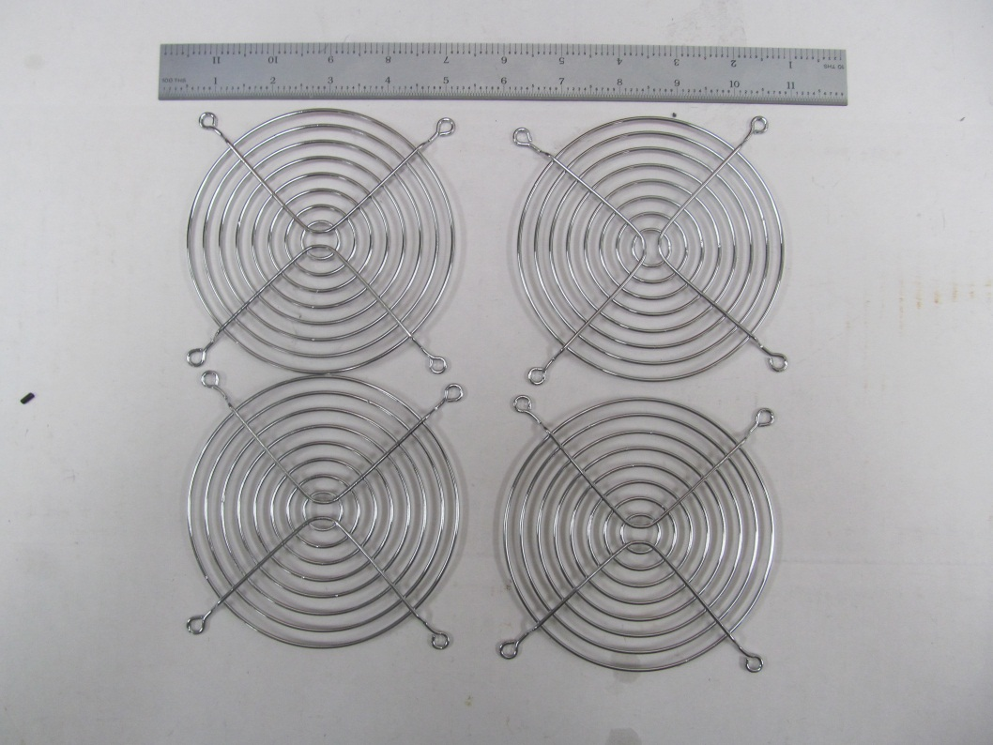

Figure 5 – Fan Guard (4)

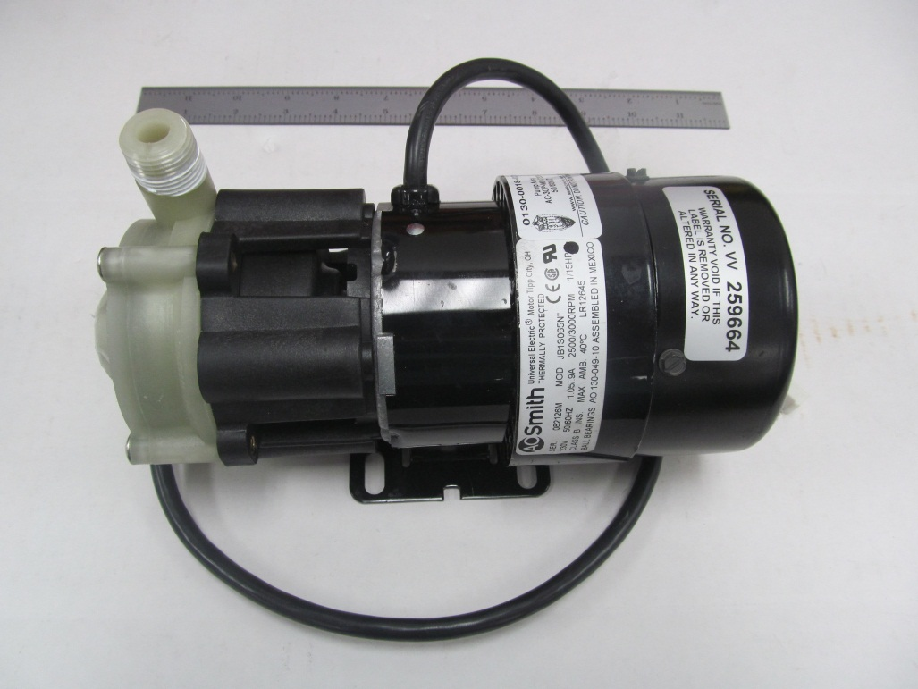

Figure 6 - 220V 1/15HP Pump

Figure 7 - Tank

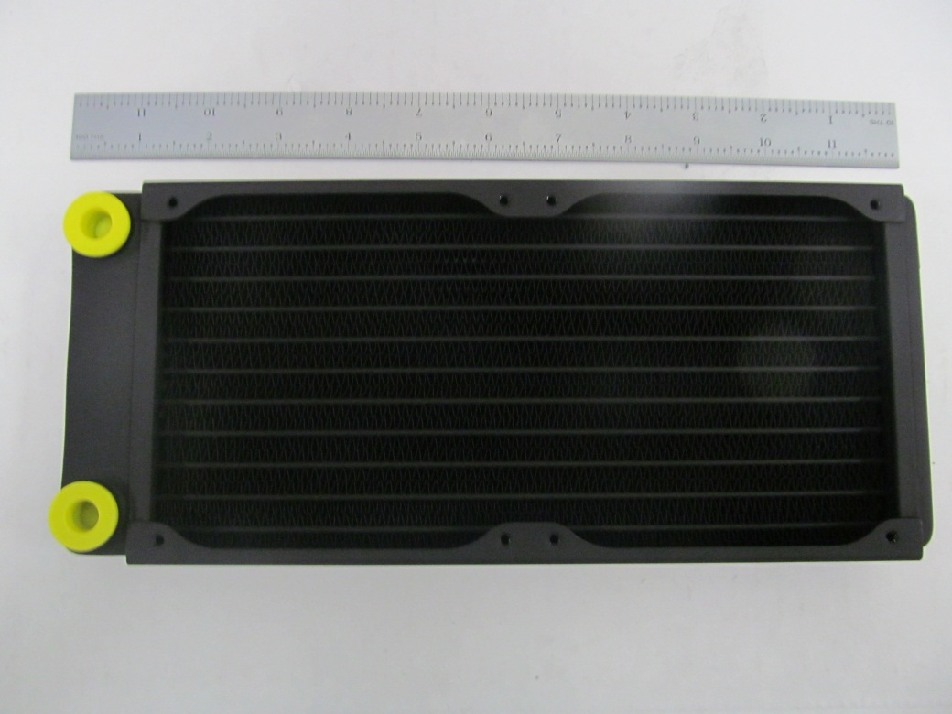

Figure 8 - Double Radiator

Figure - Athena, 4 Position Terminal Block, 9V supply and Slim Relay Mount

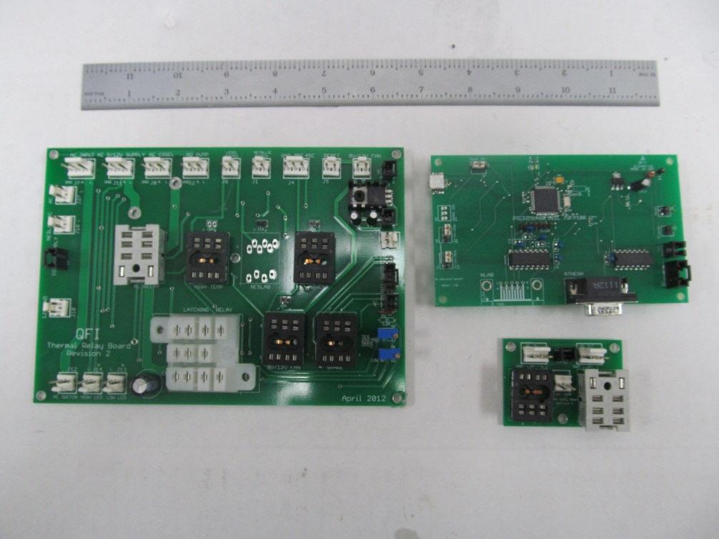

Figure 10 – Thermal Relay Board, EMO Relay Board and Thermal Microprocessor Board

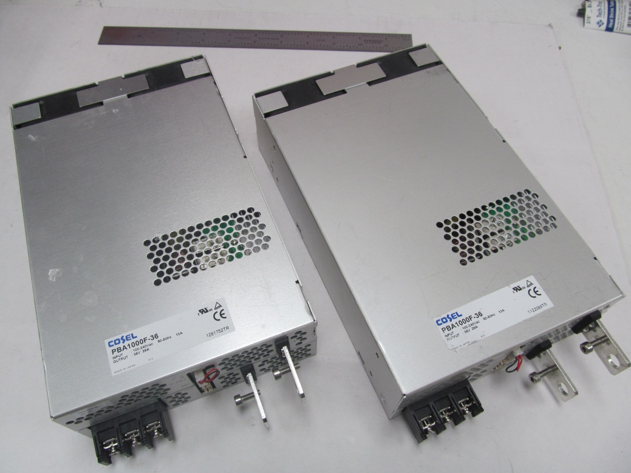

Figure 11 – 1000W 36V Power Supply (2)

Figure - Latching Relay, 220V AC Relay(2), 220V AC Relay Slim and TTL Relay(5)

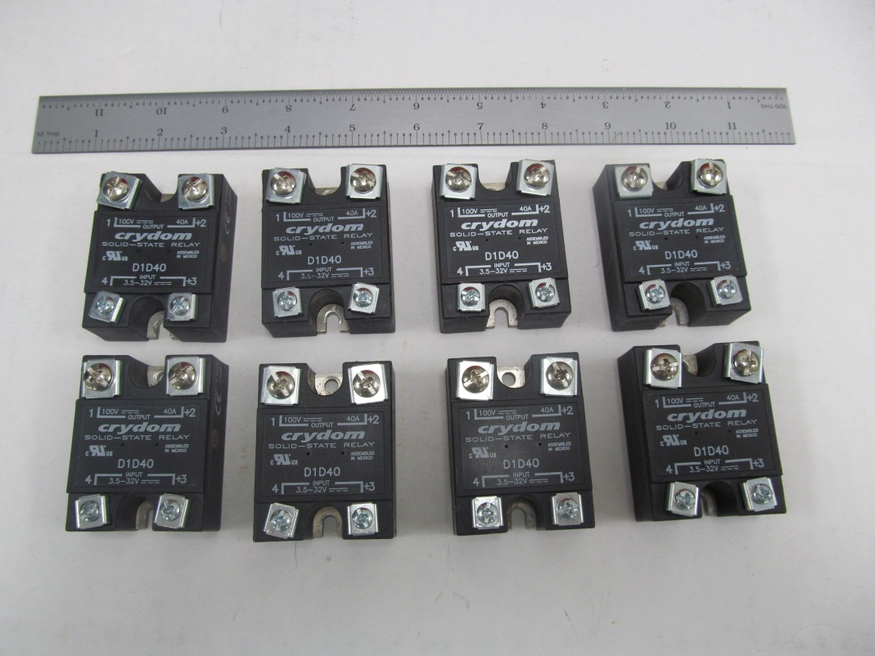

Figure - 40A Crydoms(8)

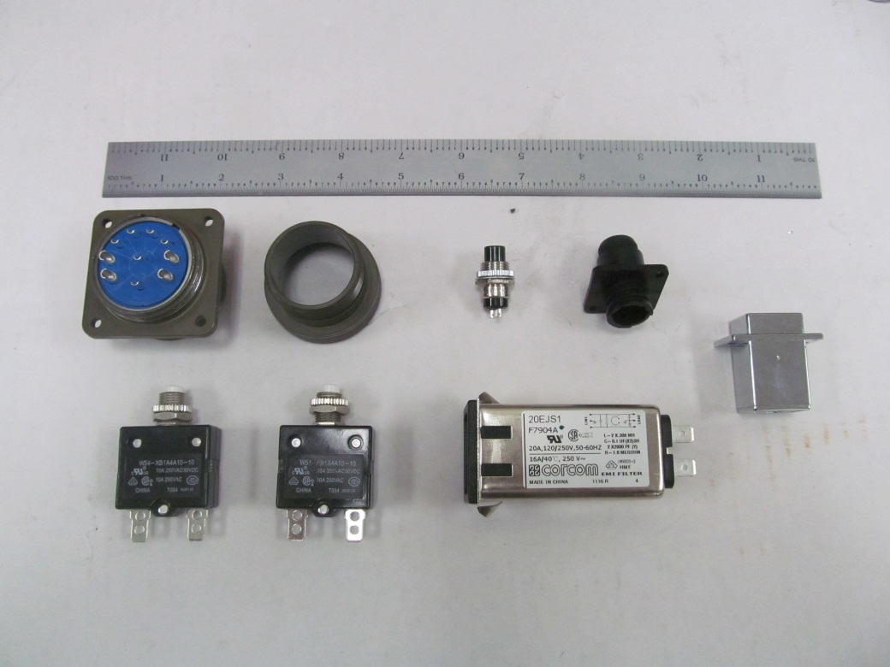

Figure - 10 Pin Connector, Reset Button, 4 Pin EMO connect, AC Inlet, U SB Connector and 10A circuit breaker(2)

Figure - 220V Green LED, 220V Red LED, AC switch and USB cable

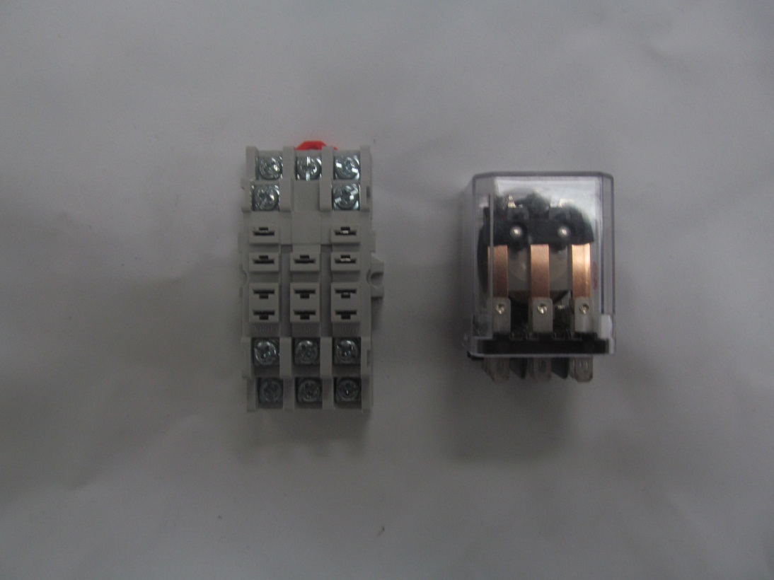

Figure - 3PDT 10A Relay and Relay Mount

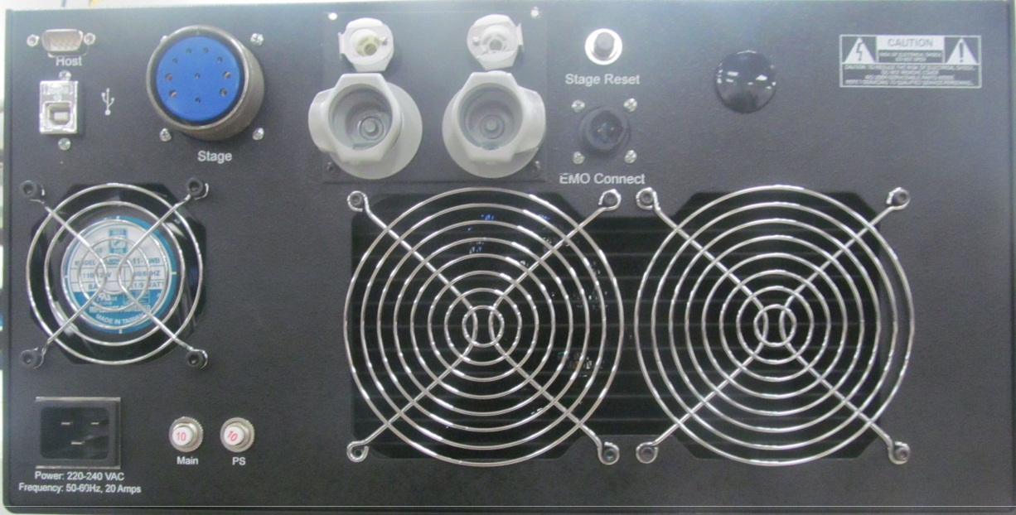

Figure - Back Panel

Figure - Front Panel (Needs Updated picture)

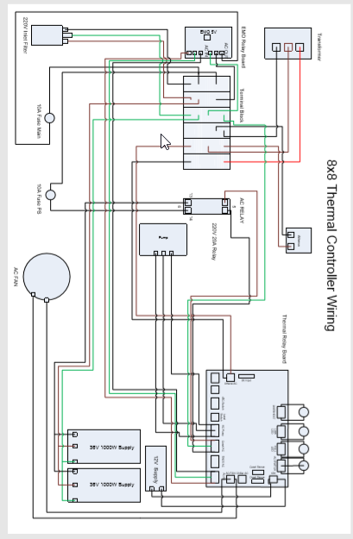

**DC Wiring:**

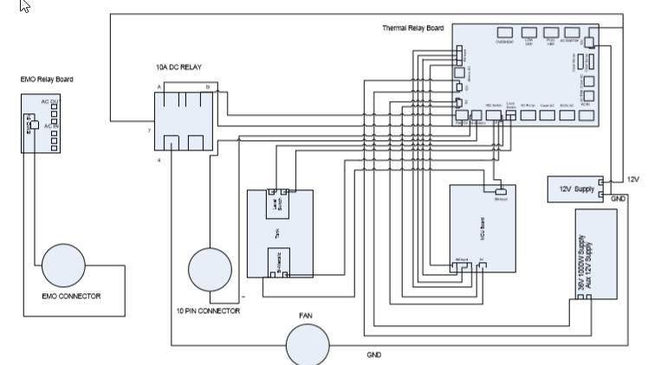

**Athena Wiring:**

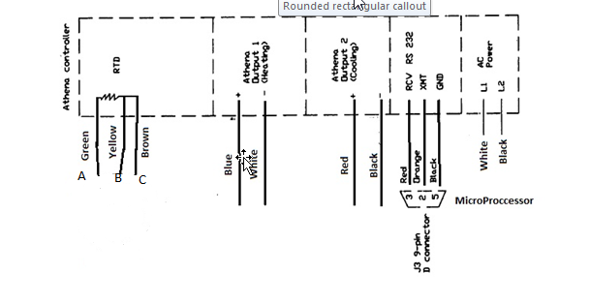

**Crydom Wiring:**

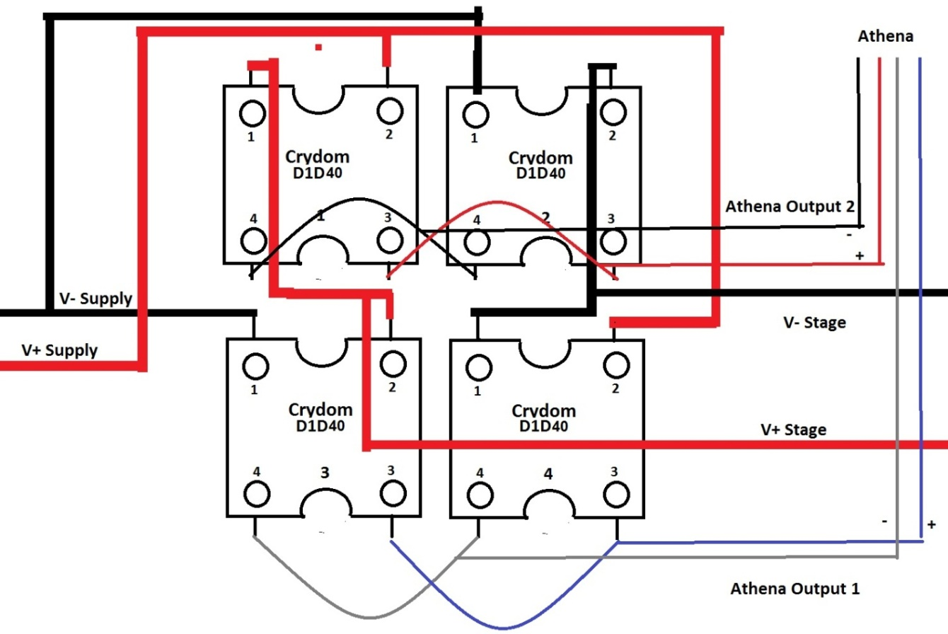

High Power 10 Pin Connector

(Stage Connector)

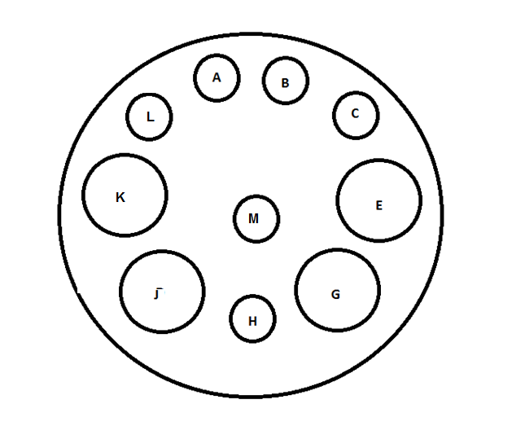

|  |  |  |
| --- | --- | --- |
| Pin # | Description | Wire Color(Gauge) |
| Pin A | RTD+ (red) | Green |
| Pin B | RTD- (white) | Yellow |
| Pin C | RTD- (white) | Brown |
| Pin E | TE+ (1) | RED(14) |
| Pin G | TE- (1) | Black(14) |
| Pin H | Bimetallic | Purple(20) |
| Pin J | TE- (2) | Black(14) |
| Pin K | TE+ (2) | RED(14) |
| Pin L | Ground | Green (16) |
| Pin M | Bimetallic | Purple(20) |